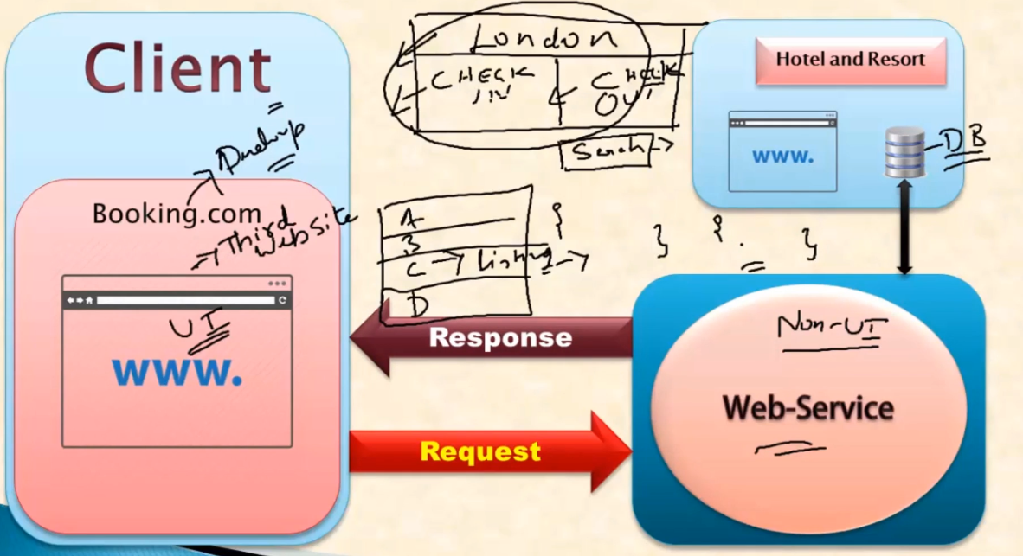

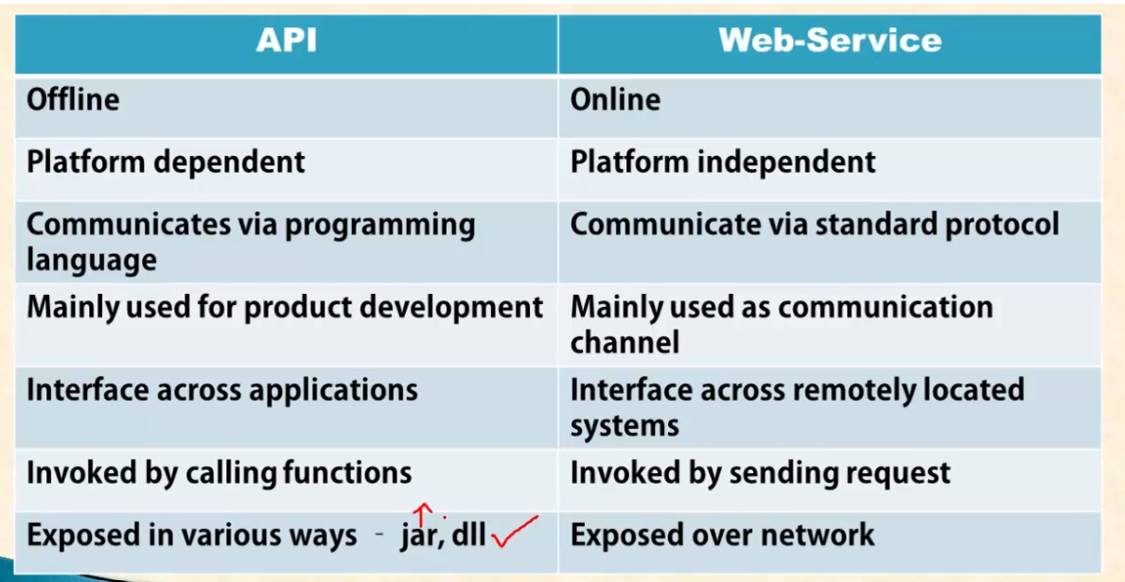

Tools need



